
UNIVERSITY OF GONDAR
COLLEGE OF INFORMATICS
DEPARTMENT OF COMPUTER SCIENCE
Software Engineering Group Project
Name ID
- Melat Melkamu……………………….GUR/02800/16

Summited to :MS Samrawit
Submission Date:Wed,nov 19/2025
Table of Contents
Chapter 1: Introduction
1.1 Introduction ……………………………………………………….1
1.2 Background ……………………………………………………….1
1.3 Core Problems of the Traditional Agricultural Market …………...2
1.4 Objectives of FarmChain Market ………………………………… 3
1.5 Scope of the Project ………………………………………………. 3
1.6 Methodology …………………………………………………….... 4
1.6.1 Requirement Gathering ………………………………………..4
1.6.2 System Analysis ………………………………………………5
1.6.3 System Design …………………………………… …………..5
1.6.4 Implementation (Coding)……………………………………... 5
1.6.5 Testing ………………………………………………………… 6
1.6.6 Deployment ……………………………………………………6
1.6.7 Documentation & Maintenance Plan ………………………… 6
1.7 Feasibility Study ………………………………………………… 7
1.7.1 Technical Feasibility …………………………………………7
1.7.2 Economic Feasibility ………………………………………… 8
1.7.3 Operational Feasibility ……………………………………… .8
1.7.4 Overall Feasibility …………………………………………… 8
Chapter 2: Requirements and Elicitation
2.1 Overview ……………………………………………………….… 9
2.2 Current System and Business Process …………………………..… 9
2.2.1 How the Current System Works ……………………………….10
2.2.2 Challenges in the Current Business Process ………………….. 10
2.2.3 Summary ……………………………………………………… 10
2.3 Proposed System ……………………………………………..…… 11
2.3.1 How the System Works ……………………………………… 11
2.3.2 Main Features ………………………………………………… 11
2.3.3 Advantages ………………………………………………….. 11
2.4 Functional Requirements ………………………………………… 12
2.5 Non-Functional Requirements …………………………………… 13
Chapter 3: System Analysis
3.1 Overview ……………………………………………………………… 15
3.2 Use Case Diagram…………………………………………………….. 16
3.3 Class Diagram ……………………………………………………….. 19
3.4 Sequence Diagram …………………………………………………… 21
3.5 Activity Diagram …………………………………………………...… 22
Chapter 4: System Design
4.1 Overview ……………………………………………………………… 24
4.2 System Architecture …………………………………………………… 24
4.3 Deployment Diagram ……………………………………………………27
4.4 Component Diagram ………………………………………………….…29
4.5 Persistent Data Model (ERD) ………..……………………………….… 31
References ……………………………………………… …………………..35

Chapter-1 Introduction
1.1 Introduction to Farmchain market
Agriculture plays a vital role in the economy of every nation. Farmers work hard to produce food and raw materials that sustain human life, yet many of them do not receive fair prices for their products. This is mainly because of the traditional marketing system, where products pass through several middlemen before reaching consumers. As a result, farmers earn less profit while consumers pay higher prices for the same goods.
In today’s digital world, technology can be used to solve this problem. FarmChain market is a simple web-based platform designed to help farmers and consumers connect directly. Through this website, farmers can easily list their agricultural products such as fruits, vegetables, and grains, along with their prices and contact information. Consumers can browse these listings and purchase fresh produce directly from the farmers, without relying on intermediaries.
This system not only improves communication between farmers and buyers but also promotes transparency, trust, and fair trade. Farmers get better income for their hard work, and consumers receive quality products at reasonable prices. Additionally, FarmChain market encourages the use of technology in rural areas, helping farmers become part of the digital economy.
By using FarmChain market, both farmers and consumers benefit from a more efficient and fair agricultural market. The platform ultimately aims to create a sustainable system where everyone gains — the producer, the buyer, and the community as a whole.

1.2 Background
In many countries, agriculture is a key source of livelihood, but farmers often face challenges in selling their products at fair prices. Traditionally, farm produce passes through multiple intermediaries, such as local traders, wholesalers, and retailers, before reaching the consumer. Each middleman adds a markup, which reduces the profit for farmers and increases the price for consumers.
Moreover, farmers in rural areas may lack access to market information, making it difficult to know the demand, set competitive prices, or find reliable buyers. Consumers, on the other hand, may not have access to fresh, locally produced goods or information about their source.
With the rapid growth of digital technology, there is an opportunity to address these challenges. Online platforms can provide farmers with direct access to consumers, allowing them to showcase their products and manage sales efficiently. Such platforms can improve transparency in pricing, increase farmers’ earnings, and provide consumers with fresh, quality produce.

FarmChain market emerges as a solution to bridge this gap by creating a simple, user-friendly website where farmers and consumers can interact directly. The system aims to modernize agricultural marketing, reduce inefficiencies, and support fair trade in local communication.

1.3 Core Problems of the Traditional Agricultural Market
- Low Profit for Farmers: Farmers often receive minimal earnings because intermediaries buy produce at low prices.
- High Prices for Consumers: Multiple middlemen increase the final cost of products, making fresh produce expensive.
- Lack of Transparency: Farmers and consumers have little visibility into pricing and profit distribution.
- Inefficient Supply Chain: Multiple layers of intermediaries cause delays, spoilage, and wastage of perishable goods.
- Limited Market Access: Farmers have restricted reach, often confined to local markets or small trader networks.
- Dependency on Middlemen: Farmers rely heavily on intermediaries for distribution, reducing bargaining power.
- Poor Communication: Direct interaction between farmers and consumers is minimal, preventing better trade relationships.

1.4 Objectives of FarmChain market:
- Create a Digital Platform Connecting Farmers and Consumers
The main goal is to build a simple, easy-to-use website that allows farmers to showcase their products and consumers to browse and purchase directly. This reduces the gap between producers and buyers and brings convenience to both parties.
- Enable Farmers to list and sell products online
  - Farmers can list their produce with details such as name, quantity, price, and images. By managing their own pricing, farmers earn fair profits and gain control over how their products are marketed.
- Provide Consumers Access to Fresh, Locally Grown Products
  - Consumers can find fresh produce from local farmers without intermediaries inflating prices. This ensures affordability while maintaining quality and freshness.
- Reduce Dependency on Intermediaries
  - By connecting farmers directly to consumers, FarmChain minimizes the need for middlemen, lowering additional costs and ensuring a fairer distribution of profits.
- Improve price transparency and product quality visibility
  - The platform provides clear information on product availability and pricing, reducing confusion and inefficiency in the market. Both farmers and consumers know exactly what they are selling or buying.
- Enhance income opportunities for farmers through wider market reach
  - By providing digital tools for marketing and direct sales, the project strengthens local farmers’ businesses, enhances their income, and encourages sustainable community-based trade.

1.5 Scope of the Project
The scope of FarmChain market defines the boundaries and purpose of the system, highlighting what the platform will accomplish. This project aims to create a digital marketplace that directly connects farmers with consumers, improving fairness, transparency, and accessibility in agricultural trade.
Key points of the project scope include:
- Direct Farmer–Consumer Interaction:
  - Farmers can list their produce online, and consumers can browse and contact farmers directly.
- Product Management:
  - Farmers can add, update, or remove product listings with details such as name, quantity, price, and images.
- Fair Trade and Transparency:
  - Consumers can view prices and product details clearly, ensuring fair transactions and promoting trust.
- Accessibility:
  - The platform is web-based and can be used by anyone with an internet connection.
- Community Focus:
  - The system primarily targets local farmers and consumers, encouraging sustainable, community-based trade.
- Ease of Use:
  - Designed with a simple and intuitive interface to accommodate users with minimal technical knowledge.

1.6 Methodology

The development of the FarmChain Market system follows a Structured System Development Life Cycle (SDLC) approach. SDLC provides a disciplined and systematic process for developing software applications through clearly defined phases. This model ensures that all activities — from identifying user needs to maintaining the deployed system — are conducted in an organized manner, minimizing risk and maximizing product quality.

The major stages of SDLC applied in this project are described below:

1.6.1 Requirement Gathering

In this phase, all functional and non-functional requirements of the system were identified. Information was collected from:

Existing literature on digital agriculture systems,

Interviews with local farmers and consumers,

Online research about agricultural e-commerce systems.

The main objective of this phase was to understand user needs — such as the need for product posting, order placement, transparency, and system usability — which later guided system design.

1.6.2. System Analysis

During this phase, the gathered requirements were analyzed to determine system feasibility, operational processes, and user interactions. A detailed study was conducted on existing agricultural marketing practices to identify inefficiencies such as middlemen dependency and price exploitation.

System modeling techniques, including Use Case, Data Flow Diagrams (DFD), and Entity Relationship Diagrams (ERD), were planned to represent system logic and workflow.

1.6.3. System Design

In this stage, the conceptual model was transformed into a structured design.

System components, data structures, interfaces, and architecture were defined.

UML diagrams we’re used to describe class relationships, data entities, and system behavior.

The design ensures modularity, scalability, and user-friendliness for both farmers and consumers.

1.6.4. Implementation (Coding)

The implementation phase involves converting the design into an operational software system.

The system will be developed using:

Front-end: HTML, CSS, JavaScript

Back-end: PHP

Database: MySQL

Each module — registration, login, product management, and order handling — is coded and tested individually before integration.

1.6.5. Testing

After development, the system undergoes rigorous testing to identify and fix errors.

Different testing techniques will be applied:

Unit Testing: Tests individual modules.

Integration Testing: Ensures modules interact correctly.

System Testing: Verifies system functionality and performance.

User Acceptance Testing (UAT): Ensures the system meets end-user expectations.

1.6.6. Deployment

Once testing confirms system stability, the FarmChain Market web application is deployed to a hosting server. Farmers and consumers can access it through a standard web browser.

Deployment also includes user account setup, database initialization, and configuration of the environment to ensure smooth operation.

1.6.7. Documentation & Maintenance Plan

All development activities are documented, including requirements, design, implementation steps, and testing reports.

A maintenance plan is also proposed to handle:

Future updates,

Bug fixes,

Feature enhancements (e.g., delivery tracking, payment gateway).

This ensures that FarmChain Market remains reliable, updated, and relevant as user needs evolve.

The SDLC methodology provides a clear framework for developing FarmChain Market from concept to deployment. It ensures systematic planning, quality assurance, and maintainability, resulting in an efficient, user-friendly agricultural e-marketplace.

1.7 Feasibility Study

Feasibility
A feasibility study evaluates whether the proposed FarmChain market system can be successfully developed and implemented, considering technical, economic, and operational aspects. This ensures that the project is realistic, viable, and capable of delivering the intended benefits.

1.7.1 Technical Feasibility
- Technology: The platform will use simple and widely-known web technologies like HTML, CSS, and JavaScript for the frontend, and PHP for backend tasks. A lightweight database like MySQL will store farmer and product data.
- Skills: The tools are easy to learn and use, so development is possible within the available time.
- Hardware: No advanced servers or expensive infrastructure are needed — even a standard computer and internet connection are enough.
Generally: FarmChain market is very achievable with the tools and skills we have.

1.7.2. Economic Feasibility
- Development Costs: Using free and open-source tools keeps costs very low.
- Maintenance Costs: Minimal, since the system is straightforward and mostly handles simple data like product listings and user information.
- Benefits: Farmers can earn more, consumers get fresh produce at fair prices, and the community benefits from better local trade.
Generally: FarmChain market is cost-effective and worth the investment.

1.7.3. Operational Feasibility
- Ease of Use: The platform is designed to be simple, so even farmers with little technical experience can use it easily.
- User Acceptance: Farmers and consumers will likely welcome it because it solves real problems like low profits and high prices.
- Effectiveness: The platform improves the market process, reduces dependency on middlemen, and ensures fairness for everyone involved.
Generally: FarmChain market is very practical and can be successfully used by the target users.

1.7.4 Overall Feasibility
FarmChain market is highly feasible. It’s simple to develop, cost-effective, and easy for users to adopt. Most importantly, it solves real problems in agriculture by connecting farmers directly with consumers, promoting fair trade, and helping the community.

Chapter -2

Requirements and Elicitation

2.1 Overview
The requirements and elicitation phase focuses on understanding what users need from the FarmConnect Market system and how the platform should function. During this stage, information was gathered from farmers, consumers, and observations of traditional market practices to identify key challenges such as unfair pricing, limited access to buyers, and lack of transparency.
The main goal was to turn these real-world problems into clear system requirements. The process involved simple interviews, observations, and reviewing similar platforms to identify useful features.
As a result, functional requirements like user registration, product listing, browsing, and direct communication were defined, along with non-functional requirements such as usability, reliability, and security.
This phase ensured that the FarmConnect Market platform would be practical, user-friendly, and effective in connecting farmers directly with consumers while promoting fair trade and transparent.

2.2: Current System and Business Process
The current agricultural marketing system mostly follows traditional methods, where farmers sell their products through several intermediaries before they reach consumers. While this approach has existed for decades, it comes with several challenges that affect both farmers and buyers.

2.2.1. How the Current System Works
- Farmers harvest their produce and sell it to middlemen or local traders at nearby markets.
- These middlemen then sell the goods to wholesalers or retailers, who finally sell them to consumers.
- In some cases, farmers sell directly in local markets, but this often limits their reach and profit.

2.2.2. Challenges in the Current Business Process
- Low Profit for Farmers:
Middlemen often buy produce at very low prices, leaving farmers with minimal profit.
- High Prices for Consumers:
By the time the product reaches the end consumer, the price has increased significantly due to multiple layers of handling.
- Lack of Transparency:
Farmers usually have no information about the market demand or final selling price of their goods.
- Limited Market Access:
Farmers are often restricted to local buyers, reducing opportunities to expand their customer base.
- Wastage and Inefficiency:
Delays in distribution and poor communication between sellers and buyers can lead to product spoilage.

2.2.3. Summary
The existing agricultural market process is inefficient and unfair to both farmers and consumers. Farmers struggle to get fair compensation for their hard work, while consumers pay more than necessary for agricultural products.
The FarmChain project aims to solve these issues by introducing a digital platform that connects farmers directly with consumers, creating a fair, transparent, and efficient marketplace.

2.3 Proposed System
The proposed system, FarmConnect, is a web-based platform designed to connect farmers directly with consumers in a fair, transparent, and efficient way.

2.3.1 How the System Works
- The admin registers farmers and creates their profiles on the platform.
- Admin can also upload and manage products for each farmer, including details like name, type, price, quantity, and photos.
- Consumers browse available products, view farmer details, and contact the farmers directly through the platform to make purchases.
- This setup ensures accuracy, security, and simplicity while still providing a direct connection between farmers and consumers.
2.3.2 Main Features
- Admin-Managed Farmer Registration: Admin creates farmer accounts and profiles.
- Product Management: Admin uploads or edits products for each farmer.
- Consumer Browsing and Search: Consumers can easily view and search products.
- Direct Communication: Consumers contact farmers directly via the platform.
- Transparent Pricing: Product prices and details are clearly visible to consumers.
- User-Friendly Interface: The platform is simple and intuitive for both farmers and consumers.

2.3.3 Advantages
- Farmers still get fair profits while the platform ensures accuracy and consistency.
- Consumers benefit from fresh, reasonably priced produce.
- Reduces complexity for farmers who may have limited technical skills.
- Maintains transparency and efficiency in transactions.

2.4 Functional Requirements
1.user registration and authentication
The system shall allow all users — farmers, consumers, and administrators — to register and log in securely using unique credentials.

2. profile managment
The system shall enable farmers to create and manage their personal profiles, including contact details and farm information.

3.product managment
The system shall allow farmers to add new agricultural products with details such as name, category, quantity, and price.
The system shall provide farmers with options to edit or delete product listings when updates are needed.

4. product browsing
The system shall allow consumers to browse all available products and view detailed product information.
The system shall include a search and filter function so consumers can easily find specific items by category, price, or name.

6.order placement
The system shall allow consumers to place orders directly for selected products.

7.order notification and confirmation

The system shall send order notifications to the respective farmers for confirmation or rejection.
8.order status update
The system shall update order status automatically after a farmer confirms or rejects an order.

9.admin management

The system shall allow the administrator to monitor user activity, manage accounts, and remove invalid or inactive users.

10.data management and storage
The system shall store all user, product, and order data in a secure centralized database with proper indexing and consistence.

11.report generation
The system shall generate simple sales or user reports for administrative purposes.

12. user session and logout
The system shall provide a logout feature to ensure secure session termination.

13.data validation and integrity
The system shall maintain data consistency between the user interface and the backend database at all times.

2.5 Non-Functional Requirements

1. performance efficiency
The system should respond to user requests within a few seconds under normal network conditions.

2.security
The system should ensure the confidentiality of all user data through secure authentication and authorization mechanisms.

3. usability
The interface should be simple, intuitive, and easy to navigate for both farmers and consumers, regardless of technical background.

4. reliability
The system should operate reliably and be available at all times except during planned maintenance.

5. scalability
The software should be designed for scalability, allowing for the addition of more users, data, and future modules such as delivery tracking or payment integration.

6. compatibility
The platform should be compatible with common web browsers and accessible on both desktop and mobile devices.

7. maintainability
The system should validate all inputs to maintain data integrity and prevent incorrect or duplicate records.
8.data integrity
The design and source code should be modular and well-documented to simplify future maintenance and updates.
9. error handling and recovery
The system should recover gracefully from unexpected errors or interruptions without data loss.

10. concurrency
The user interface and database should support multiple concurrent users without performance degradation.

11. confidentialiityThe system should employ encryption for passwords and sensitive transactions to ensure data security.

Chapter 3

System Analysis
3.1 Overview
System analysis helps to understand the functional flow architecture, and interaction with in FarmChain Market.it explains how users communicate with in the system and how data flows between components. identifying its weaknesses, and understanding what the new system should do to solve those problems.
The analysis phase use modeling tools such as Use case diagram, class diagram, sequence diagrams and activity diagrams to describe user interaction and system behavior.
For FarmChain Market, the analysis focused on:
- Problems in the Current System:
  - Farmers earn low profits due to middlemen.
  - Consumers pay higher prices for produce.
  - Lack of transparency and limited market access.
  - Inefficiencies leading to delays and wastage.
- Proposed System Goals:
  - Create an admin-managed digital platform connecting farmers directly with consumers.
  - Ensure fair pricing, transparency, and a smooth online shopping experience.
  - Make the system easy to use for both farmers and consumers.
- Feasibility Considerations:
  - Technically achievable with simple web technologies.
  - Economically viable and low-cost.
  - Operationally practical and user-friendly.
The system analysis confirms that FarmConnect addresses the shortcomings of the traditional market by providing a transparent, efficient, and fair platform for both farmers and consumers.
3.2 Use Case Diagram
A use case diagram visually represents the interaction between users (actors) and system , outlining the primary functionality the system will offer.
Actors
Farmer
Consumer
Delivery agent
Admin
key use cases(high-level): the diagram would show the following major functionalities, each connecting one or more actors:
- Farmer
- register,
- login,
- manage products,
- view orders,
- update status

- Consumer:
- register,
- login,
- browse products,
- place order,
- rate and review,
- track order.
- Delivery agent
  - login
  - view deliveries
  - update delivery status
- Admin
- Manage users
- Manage products
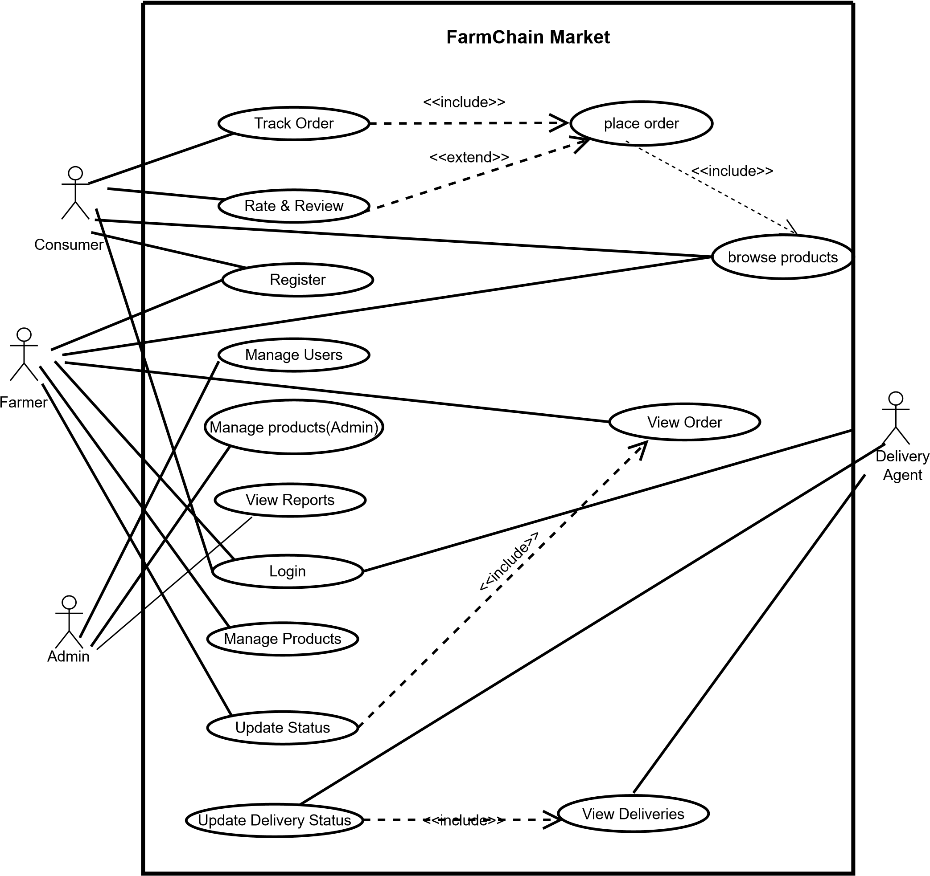
Figure 1: use case diagram

Description of Actors and Use Cases
- Farmer: Registers and logs into the system, manages products, views orders, and updates order status.
- Consumer: Registers and logs in, browses products, places orders, tracks orders, and rates products.
- Delivery Agent: Logs in, views assigned deliveries, and updates delivery status.
- Admin: Manages user accounts, manages products, and generates system reports.
The Use Case Diagram ensures that all primary system functionalities are captured and serves as a reference for design and implementation.

3.3 Class Diagram

The Class Diagram shows the static structure of the system, detailing entities, their attributes, methods, and relationships. It forms the basis for database design and software implementation.
Description of Classes
- User: Represents all system users with attributes such as user_id, name, email, password, and role.
- Farmer: Linked to User, with attributes farmer_id, farm_name, contact_info. Can manage multiple products.
- Consumer: Linked to User, with attributes consumer_id, address, phone. Can place multiple orders.
- Product: Represents agricultural items, attributes include product_id, name, category, quantity, price, and image. Linked to a farmer.
- Order: Tracks purchase transactions with attributes order_id, order_date, status, total_amount, consumer_id, and product_id.
- Delivery: Tracks delivery status, with attributes delivery_id, agent_id, order_id, and delivery_status.
The Class Diagram establishes the relationships between entities and ensures data integrity in the database.

user
name
email
role
password
User_id
login
logout
Farmer
farmer id

contact info
farmer name
Add_products
view_orders
Consumer
Consumer_id
Phone
Adress
place_order
browse_products
rate_products
Delivery
Delivery_id
Delivery_status
agent_id
delivery_date
Assign_agent
Update_delivery_status()
product
product_id
catagory
quantity
name
image
update_info()

delete_product()
price
Order
Order_id
Status
total_amount
order_date
Cancel_order
View_order_detail
Create_order
edit_products
1
*
*
*
1
*
1
1
Figure 2: class Diagram

3.4 sequence Diagram
Sequence Diagrams illustrate object interactions over time, showing the sequence of messages exchanged to perform a specific task.

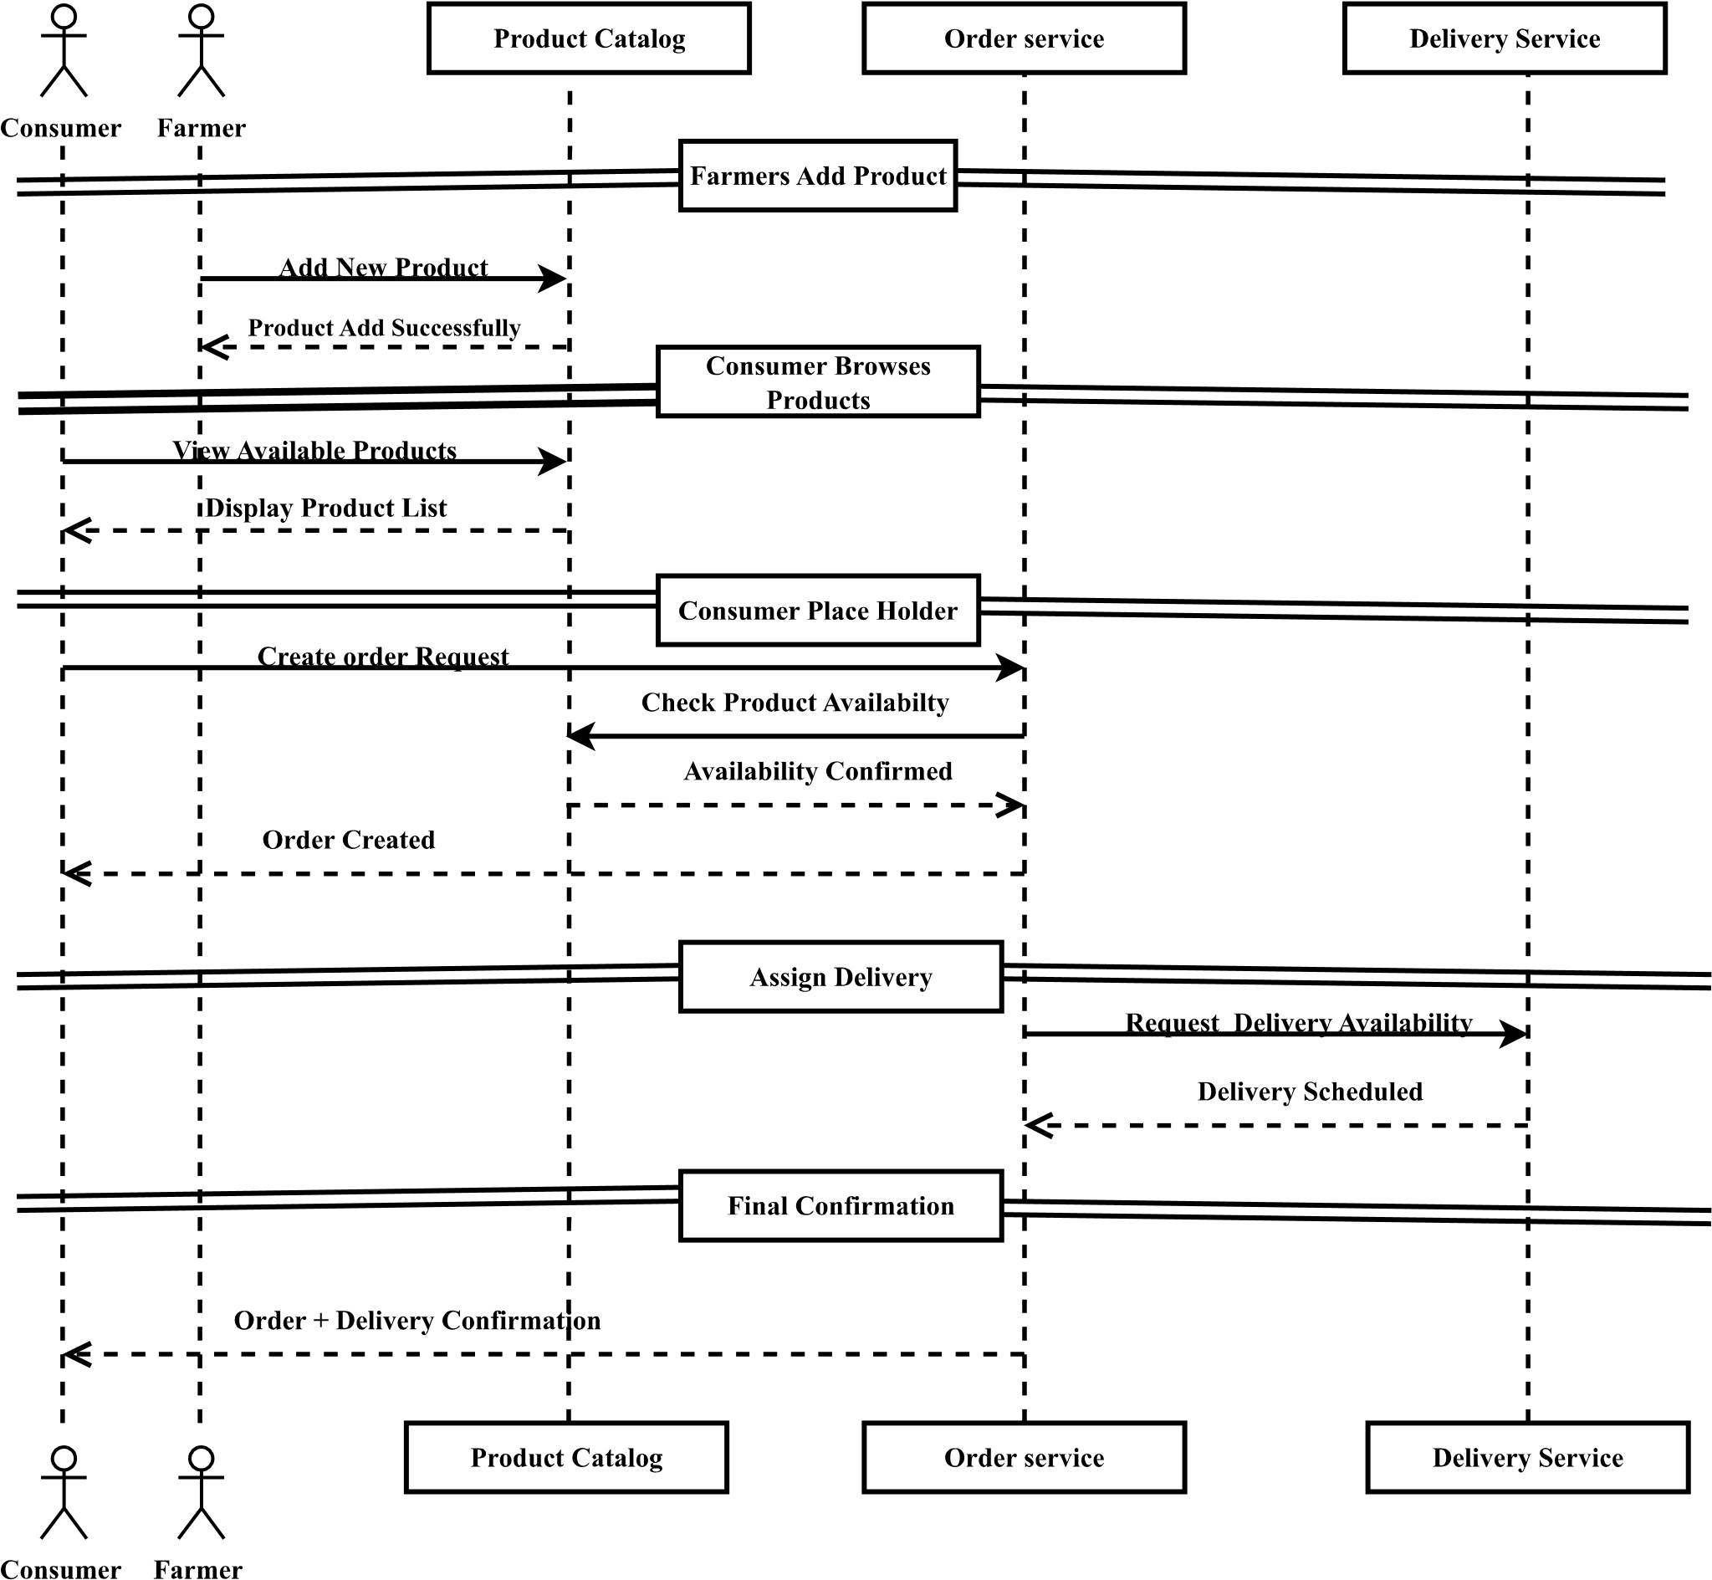
Figure 3: sequence Diagram

Description
- Consumer selects a product and places an order.
- System verifies product availability.
- Order details are sent to the farmer for confirmation.
- Farmer confirms the order; system updates order status.
- Delivery agent is assigned and updates delivery status.
Sequence diagrams help developers visualize dynamic behavior and interactions between system components.
3.5 Activity Diagram
Activity Diagrams describe workflows and processes, representing the flow of control from one activity to another, including decisions and parallel tasks.

login as farmer
Product exists?
NO
Yes
Add new product
Update Product
Submit products info
Save to Database
Open product managment
Figure 3: Activity Diagram
Description
- Depicts the step-by-step process of browsing products, placing orders, and tracking deliveries.
- Includes decision points, such as out-of-stock items or order rejection.
- Facilitates understanding of system logic and user interactions.

Chapter -4
System Design

4.1 Overview
The design phase is one of the most critical stages of software development. It translates the system requirements identified during analysis into a well-structured technical model that will guide implementation. In the case of FarmChain Market, the system design defines the architecture, data model, components, and interactions that make up the web-based agricultural trading platform.
The main objective of the design phase is to produce a blueprint that describes how the system will operate in terms of:
- Software architecture
- Data organization and relationships
- Component interaction
- System deployment environment
The FarmChain Market system follows a structured and modular design approach to ensure scalability, maintainability, and security. Each module performs a specific role — for example, the User Module handles authentication, the Product Module manages product listings, and the Order Module manages purchase requests and delivery coordination.
This modular design allows for easier debugging, enhancement, and future feature integration such as mobile access, payment gateways, and delivery tracking.

4.2 System Architecture
The overall architecture of the FarmChain Market system is based on a Three-Tier Web Architecture, which separates the system into three logical layers: the Presentation Layer, the Application Layer, and the Data Layer.
1.Presentation Layer
This is the front-end of the system where users (farmers, consumers, administrators, and delivery agents) interact through a web browser. It is designed with HTML, CSS, and JavaScript, ensuring that the interface is user-friendly, responsive, and easy to navigate.
Key responsibilities of this layer include:
- Displaying product listings, orders, and reports
- Capturing user inputs such as login credentials or product details
- Sending requests to the application layer
- Presenting processed data in a clear, visual form
2. Application Layer (Business Logic)
The middle layer handles all logical operations of the system. It is implemented using PHP, which serves as the connection between the user interface and the database. This layer processes user requests, applies business rules, validates data, and determines what information should be stored or retrieved.
Key responsibilities include:
- Managing user authentication and access control
- Processing product registration and updates
- Handling order placement and delivery assignment
- Performing input validation and enforcing business logic
3. Data Layer (Database Management)
This layer stores and manages all persistent data used by the system, such as user accounts, product details, orders, and delivery information. The MySQL database system is used due to its reliability, security, and compatibility with PHP.
Key functions of this layer include:
- Storing and retrieving structured data
- Maintaining referential integrity and relationships
- Executing SQL queries for CRUD (Create, Read, Update, Delete) operations
- Ensuring data consistency, backup, and recovery
Together, these three layers work cohesively to form a robust and secure web-based marketplace that facilitates fair and transparent transactions between farmers and consumers.

4.3 System Architecture Diagram
The architecture diagram illustrates how the three layers interact. The client browser sends HTTP requests to the web server, where the PHP-based business logic processes the request and communicates with the MySQL database. The processed results are then returned to the browser as HTML pages, which the user views and interacts with.
Presentation layer

Client Browser
Application layer
Web Server /PHP Application
Presentation layer
MY SQL Database
HTTP/HTTPS Requests HTML Responeces
SQL Queries Data Responses
Figure 4: System Architecture Diagram

4.3 Deployment Diagram
The deployment diagram describes the physical configuration of the FarmChain Market system, showing how software components are distributed across hardware nodes.
SQL Queries Return results
CLIENT DEVICE
Browser
Web Server
PHP application
Data base Server
MY SQL Database
HTTP/HTTPS HTML/JS Pages

Figure 5: Deployment Diagram

Hardware Nodes:
- Client Node (User Devices):
  - Represents devices used by farmers, consumers, admins, and delivery agents.
  - Each device uses a web browser to access the system through the internet.
- Web Server Node:
  - Hosts the PHP application, the business logic, and user interface files.
  - Handles HTTP/HTTPS requests and responses.
  - Manages session control, user requests, and interaction with the database.
- Database Server Node:
  - Runs the MySQL database that stores all persistent data.
  - Communicates with the web server through a secure connection (typically Port 3306).
Communication Links
- The Client Node communicates with the Web Server using HTTP or HTTPS.
- The Web Server communicates with the Database Server through SQL queries and secure database connections.
This setup ensures separation of concerns — the client handles presentation, the web server handles business logic, and the database manages data storage. Such separation enhances security, scalability, and system reliability.

4.4 Component Diagram
The component diagram describes how the software system is divided into reusable, modular parts (components) and how they interact.
authentication Componenet
Product management Component
Delivery management Component
User Interface
Report Generation Components
Order management Component
Database Access Component
MY SQL Database
Figure 6: Component Diagram

Main Components:
- User Interface Component: Handles all user interactions and input forms (login, registration, product posting, browsing, etc.).
- Authentication Component: Manages login, registration, password encryption, and user session control.
- Product Management Component: Allows farmers to add, edit, delete, or view their products.
- Order Management Component: Handles order placement, confirmation, rejection, and tracking.
- Delivery Management Component: Manages delivery agent assignments and status updates.
- Report Generation Component: Allows the admin to generate reports on sales, users, and platform activity.
- Database Access Component: Acts as an intermediary between the business logic and the MySQL database, ensuring all CRUD operations are secure and optimized.
Each component can be developed and tested independently. The use of modular components improves system maintainability and makes future updates, such as payment integration or AI-based price suggestions, easier to implement.

4.5 Persistent Data Model (ERD)
The Entity Relationship Diagram (ERD) defines how data entities relate to each other within the database. The main entities in FarmChain Market include User, Farmer, Consumer, Product, Order, and Delivery.
User
user_id
name
email
password
role
Farmer
Farmer_id
Farm_name
Contact_info
User_id
Consumer
Consumer_id
Adress
phone
User_id
Product
Product_id
name
catagory
quantity
price
image
farmer_id
Order
Order_id
order_date
Status
Total_amount
consumer_id
Delivery
Delivery_id
Agent_id
Order_id
Delivery_status
Has
has
Manages
places
Assigned to
Includes in
Figure 7: Persistent Data Model (ERD)

Entity Descriptions:
1. User
Represents all users of the system including admins, farmers, consumers, and delivery agents.
Attributes: user_id, name, email, password, role
Relationships:
- A user can be a farmer, consumer, or admin depending on the role.
2. Farmer
Represents farmers who list agricultural products for sale.
Attributes: farmer_id, farm_name, contact_info, user_id (FK)
Relationships:
- Each farmer is linked to a single user account.
- A farmer can manage multiple products.
3. Consumer
Represents customers who browse and purchase products.
Attributes: consumer_id, address, phone, user_id (FK)
Relationships:
- Each consumer is linked to a single user account.
- A consumer can place multiple orders.
4.product
Represents the agricultural items sold on the platform.
Attributes: product_id, name, category, quantity, price, image, farmer_id (FK)
Relationships:
- Each product belongs to one farmer.
- A product can appear in multiple orders.
5 order
Represents purchase transactions made by consumers.
Attributes: order_id, order_date, status, total_amount, consumer_id (FK), product_id (FK)
Relationships:
- Each order is placed by one consumer for one or more products.
- Each order can have one delivery record.

6.Delivery
Represents delivery tracking and agent assignment.
Attributes: delivery_id, agent_id (FK), order_id (FK), delivery_status
Relationships:
- Each delivery is assigned to a specific order and handled by one delivery agent.
This data model supports data integrity through foreign key constraints and ensures that all relationships between entities (like farmer-product and order-delivery) are properly maintained. It allows easy retrieval of information for reports, audits, and performance analysis.

References
- Pressman, R. S., & Maxim, B. R. (2020). Software Engineering: A Practitioner’s Approach (9th ed.). McGraw-Hill Education.
- Sommerville, I. (2016). Software Engineering (10th ed.). Pearson Education.
- Dennis, A., Wixom, B. H., & Roth, R. M. (2018). Systems Analysis and Design (7th ed.). Wiley.
- Fowler, M. (2004). UML Distilled: A Brief Guide to the Standard Object Modeling Language (3rd ed.). Addison-Wesley.
- Kendall, K. E., & Kendall, J. E. (2019). Systems Analysis and Design (10th ed.). Pearson.
- Connolly, T., & Begg, C. (2015). Database Systems: A Practical Approach to Design, Implementation, and Management (6th ed.). Pearson.
- W3Schools. (2024). HTML, CSS, and JavaScript Tutorials. Retrieved from https://www.w3schools.com
- MySQL Documentation. (2024). MySQL Developer Guide. Oracle Corporation.
- FAO. (2023). Digital Agriculture: Supporting Farmers Through Technology. Food and Agriculture Organization of the United Nations.
- Singh, G., & Kaur, P. (2021). “E-Agriculture and Digital Marketplaces: A Study on Farmer-to-Consumer Platforms.” International Journal of Computer Applications, 174(21), 1-7.

